Portfolio Card (100 points)
Create a Web page (HTML5 + CSS3) that looks like the screenshot below:
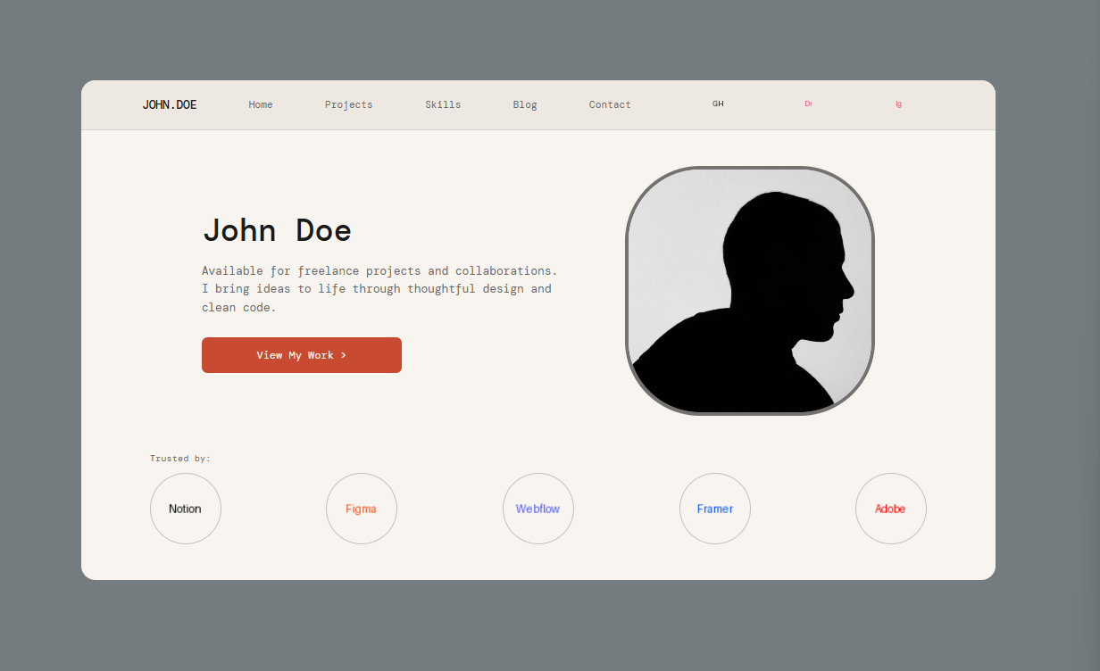

Output
The output should be valid HTML5 + CSS3 that implement the above web page.
- Use font 'IBM Plex Mono' – (https://fonts.googleapis.com/css2?family=DM+Mono:wght@300;400;500&display=swap)
- The site should open correctly in the latest version of Chrome

How to Submit the Assignment
- Folder Structure Your folder must be named exactly: 01_Portfolio_Card_Task and contain the following files:
  - index.html
  - styles.css
  - images/ (folder with images)

- Package all three tasks into one .zip file, with each task in its own separate folder following the naming convention above

